Airline Analysis - 2024

# 1 Introduction

## 1.1 Overview

The Airline Analysis Project aims to analyze and disclose trends inside the air carrier

manufacturing using a dataset that contains itemized information on air carrier leaving

dates for the old age 2022. This project involves diversified stages of data conversion,

imagination, and interpretation to determine litigable judgments for stakeholders inside

the manufacturing. The air carrier industry is a complex and vital area, heavily affected

by miscellaneous determinants such as migratory demand, financial environments,

geopolitical events, and mechanics progress. Understanding these determinants

through data reasoning can specify valuable insights for functional adeptness, clever

planning, and client delight.The dataset in focus includes airline leaving dates for the old

age 2022. It contains critical news to a degree:Departure Date: The particular date on

which each departure departs.Origin and Destination: Each departure's starting point

and goal.Flight Status: Indicates either the departure was on occasion, postponed, or

canceled. This dataset is an important resource for resolving miscellaneous currents

and patterns within the air carrier manufacturing. By checking departure dates, we can

reveal intuitions related to peak travel periods, the impact of extrinsic occurrences, and

operational depiction.

## 1.2 Purpose

Identify Travel Trends,Operational Efficiency,Impact of External Events,Route

Analysis,Identify Bottlenecks: By resolving dossier on departure departures, delays, and

cancellations, airlines can define functional incompetences and fields that demand

bettering.Data-Driven Decisions: Insights from the reasoning allow airlines to make

cognizant clever conclusions. For example, route celebrity dossier can guide airlines in

optimizing departure schedules, presenting new routes, or ceasing underperforming

one, eventually reconstructing appropriateness and consumer vindication.Mitigate

Impacts of External Events: Analyzing by means of what extrinsic occurrences like

geopolitical conflicts or financial changes influence movements helps airlines evolve

possibility plans and adapt more fast to disruptions.

## 

## 1.3 Technical Architecture

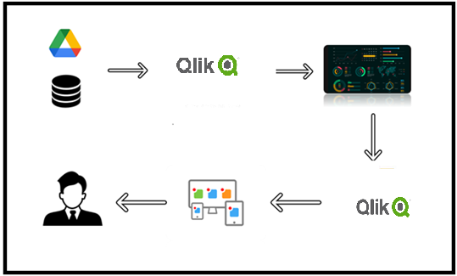

# 2.Define Problem/ Problem Understanding

## 2.1 Specify the business problem

the following are the business problems which need to be solved:

● Revenue Optimization

● Operational Efficiency

● Customer Experience Enhancement

## 2.2 Business Requirements

1. Data Collection and Integration(dataset)

2. Data Storage and Management Scalable Data Storage:

3. Analytical Capabilities

4. Operational Efficiency Analysis

5. Customer Insights and Personalization

6. Revenue Management and Pricing Strategies

7. Impact Analysis of External Factors

2.3 Literature Survey

Based upon the provided data it is understood that we have to enhance

# 3.Data Collection

## 3.1 Collect the Dataset

The data have been extracted from the airline dataset available at kaggle in the

following link:

https://www.kaggle.com/datasets/iamsouravbanerjee/airline-dataset/data

## 3.2 Connect Data with Qlik Sense

Data has been connected with qlik sense by loading the data which is done by creating

a new app and then adding data by load data as an option and then selecting the data

which is in the excel form in the file manager

# 4.Data Preparation

## 4.1 Prepare the data for Visualization

the data preparation has been carried out by formatting and making sure that null

values are identified and corrected.Ensuring that analyses are accurate, reliable, and

insightful. This preparation will enable you to create compelling visualizations that

reveal key trends and insights, ultimately supporting better decision-making within the

airline industry

# 5. Data Visualisation

## 5.1 Total Number of Passengers



## 5.2 Passengers with Cancelled Flights



## 5.3 Passengers with delayed Flight



## 5.4 Passengers with Flight On Time



## 5.5 Count of Passengers Travelled Month wise

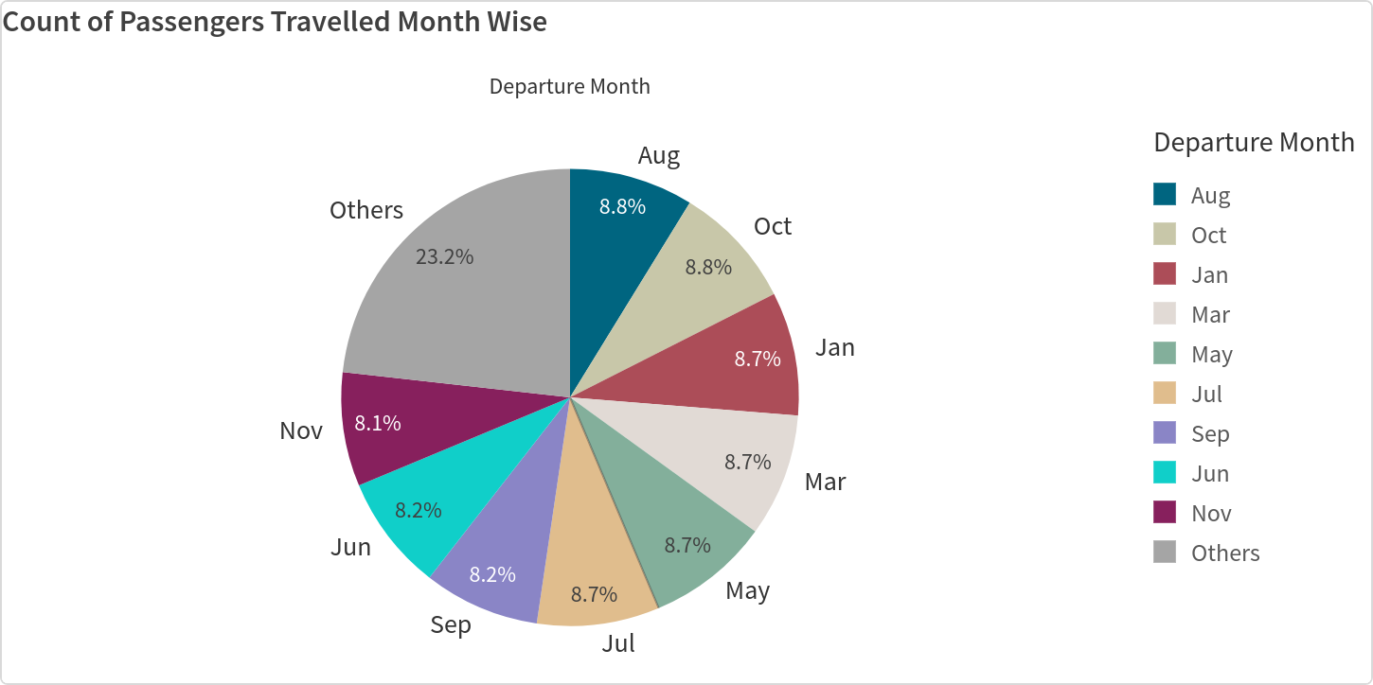

5.6 Passengers and their Age groups

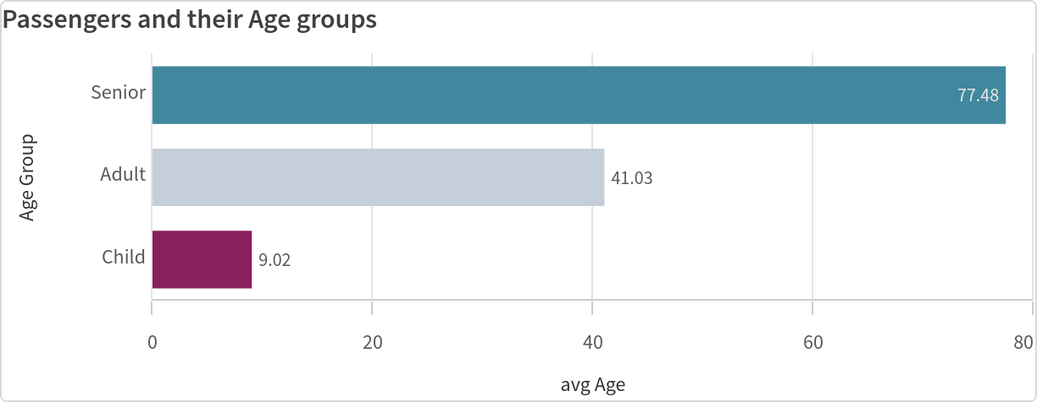

## 5.7 Passengers and Nationality

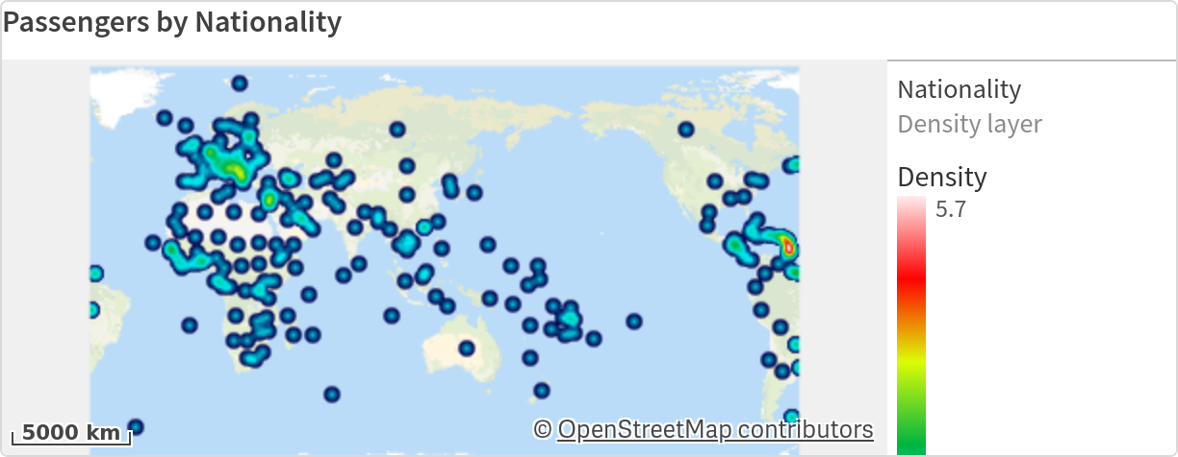

## 5.8 Passenger Names and Nationality

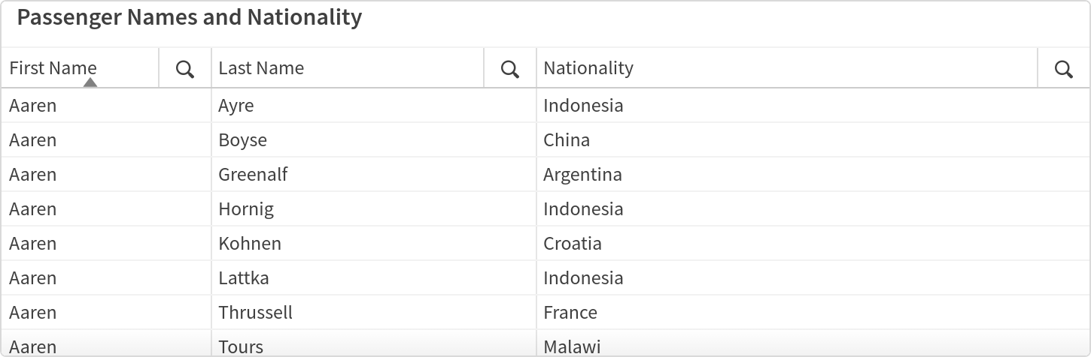

## 5.9 Flight status across diff age group

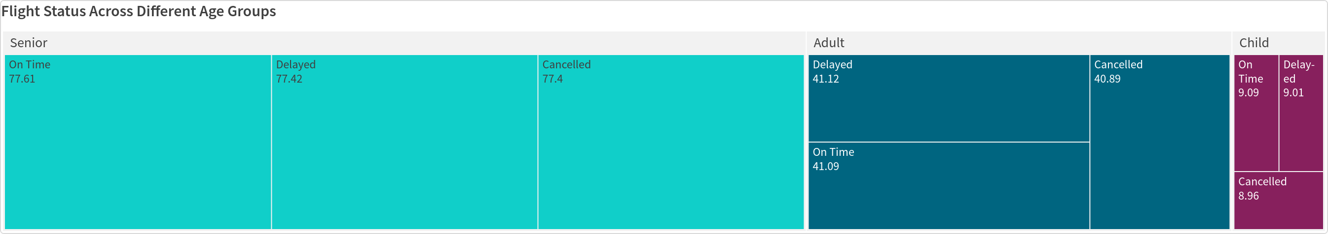

## 5.10 Gender Distribution Age group wise

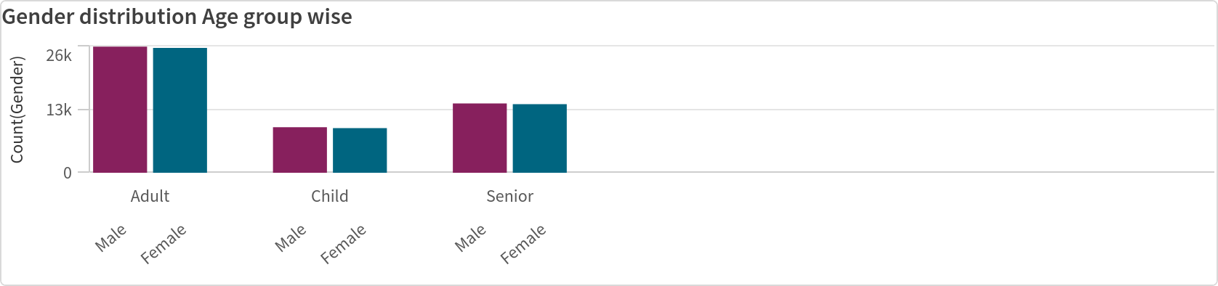

## 5.11 Flight Performance

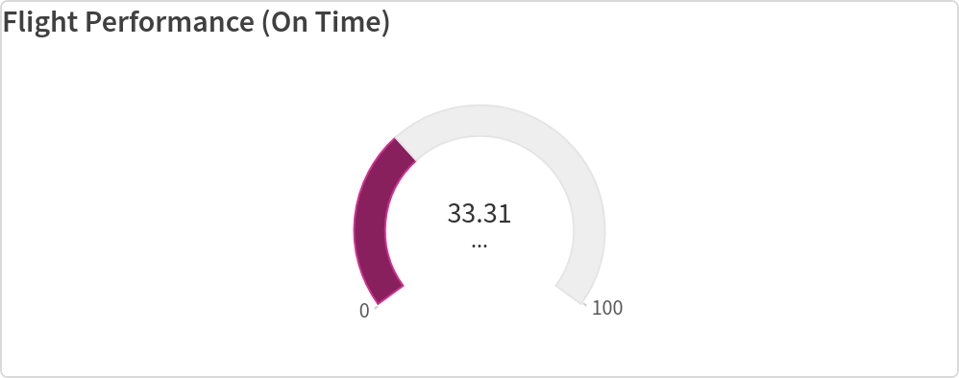

## 5.12 Flight status by Continents

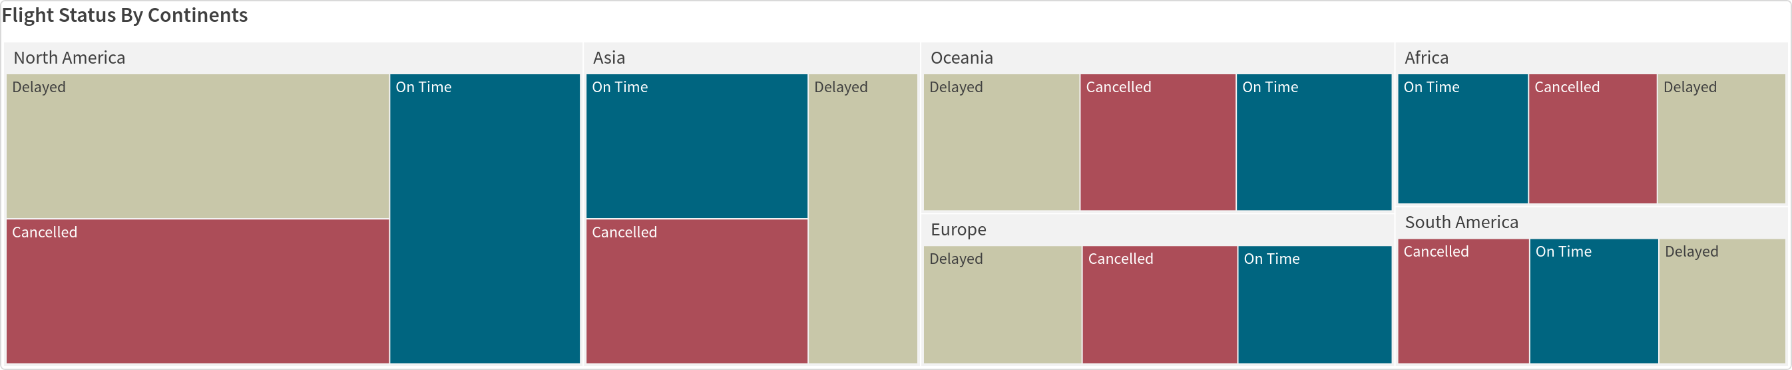

## 5.13 Max Passenger inflow

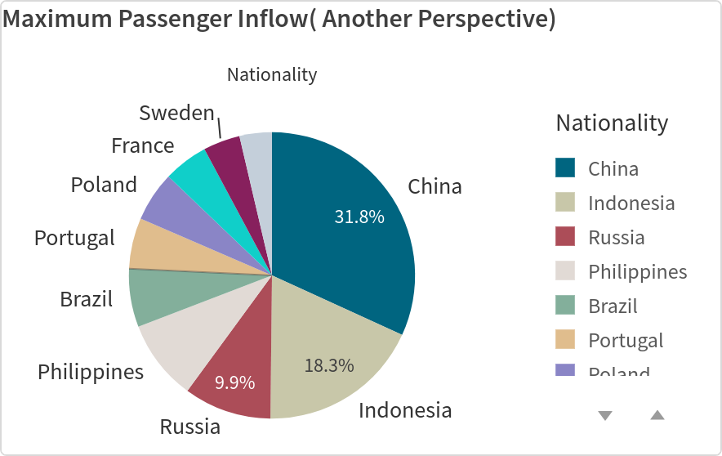

## 5.14 Punctual pilots

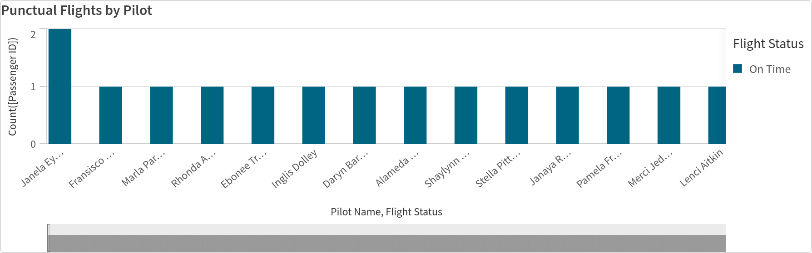

# 6.Dashboard

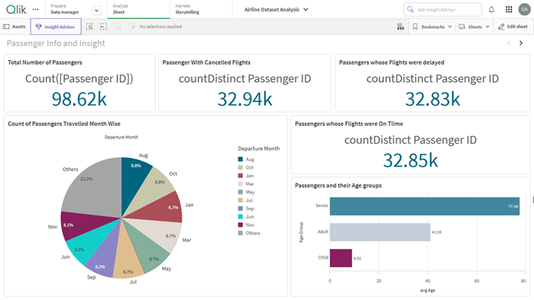

fig 6.1: This Dashboard shows the basic Data Visuals such as Count of passengers, Age groups among them and thier count based on Flight status

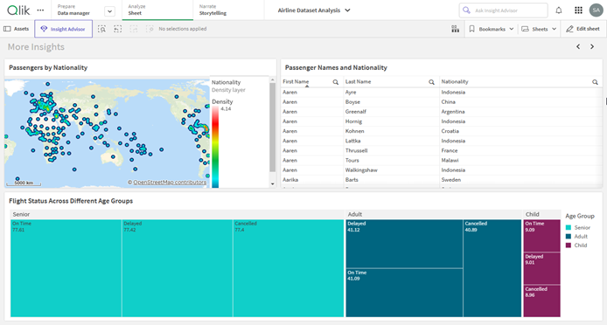

fig 6.2: This Dashboard Shows the Passnegers Distribution of nationality on a map, their full names and the Flight status based on different different age groups

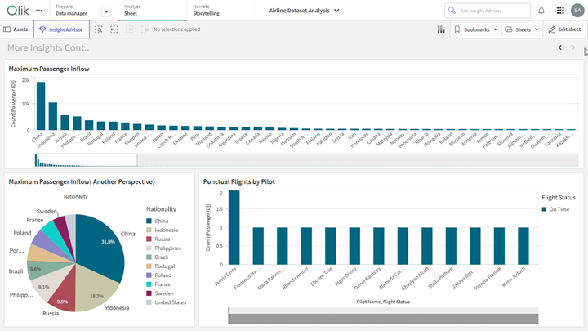

fig 6.3: This Dashboard Shows Maximum Passenger Inflow from which country they belong to and the Pilots who landed their flight on Time

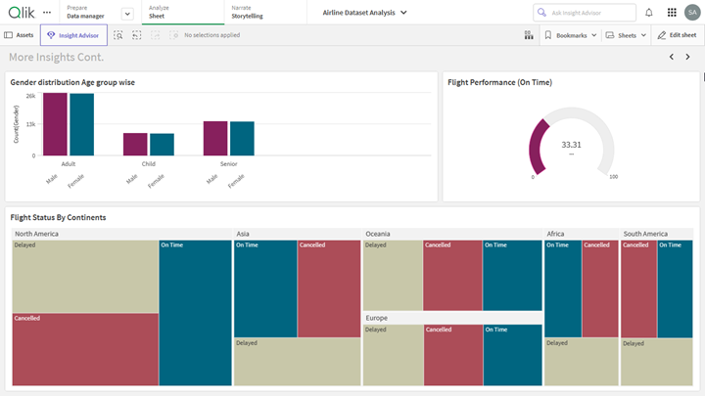

fig 6.4: This Dashboard shows the Gender Dristibution by age group, Flight performance in terms of On time Flights and Flight status by countinents

7.Report

7.1 Report Creation

From above visualizations, of airline 2022 dataset the possible problems an airline may  
face are  
1.Flight delays and cancellations  
2.Financial Challenges  
3.Safety Regulations  
4.Competition  
5.Technological Challenges  
6.Customer/Passenger Satisfaction Challenges  
7.External Factors

8.Labor shortages/disputes

Solution: In order to overcome these Challenges based on the provided data Each  
country has its own demographics and different bioms and lies on different latitude and  
longitude having a unique pattern of weather. Understanding the weather pattern would  
have a plus point in operating ﬂights  
Which is an important factor for maintaing a safe and secure movement of passenger.  
this will avoid the delay and cancellation.some of the factors which can be a reason for  
delay or cancellation can be ﬁnancial challenges or external factors. In the world of  
extreme competition, it is crucial operating an airline needs to focus on all the possible  
paths.Financial challenges ma appear due to lack of customer satisfaction and quality  
of hospitality and maintenance. Let us Consider few cases of External factor and a  
general/neutral Cases

8.Performance Testing

8.1 Amount of data Rendered

The variety of data that have been collected, processed and prepared includes the

dataset airline 2022 which consist of 98,620 rows of data consisting of ﬁrst name, last  
name,passenger ID, age, gender, arrival airport, Pilot names, departure dates and ﬂight  
status. Now the amount of data that has been loaded into qlik sense is 15 columns and  
98,619 Rows. out of which their was missing data which was later replaced by null value  
similarly date formatting has also been carried out on the data.  
8.2 Utilization of Data Filters

Data ﬁlters played a crucial role in tuning themselves with various properties. such as  
narrowing to speciﬁc segments or criteria making it easier to focus on relevant  
information.it helps in improving performance by ﬁltering out the unnecessary data,  
reducing time and leading to faster response time and smoother experience. it also  
makes the entire visualizations more interactive and engaging experience. provides  
better insights

****************************************************************************************************